Activity:
Water Pump Function

Description:
This program will consist of a function that will water a plant based off the soil moisture.
Vocabulary and Concepts:
Soil Moisture Sensor: sensor that estimate volumetric water content
Iteration (Loop): A repetitive action or command typically created with programming loops. Loop
action of doing something repeatedly.
Control: The power to direct the course of actions. In programming, the use of elements of programming code to direct which actions take place and the order in which they take place. A programming (code) structure that implements control. Selection (“if” statements) and loops are examples of control structures.
Function: A named piece of code that can be called repeatedly, sometimes called procedures or methods: a segment of code that includes the steps performed in a specified process.

Flowchart:
A flowchart is a way of representing the step-by-step process (algorithm) of you
program. For this program, the flowchart is
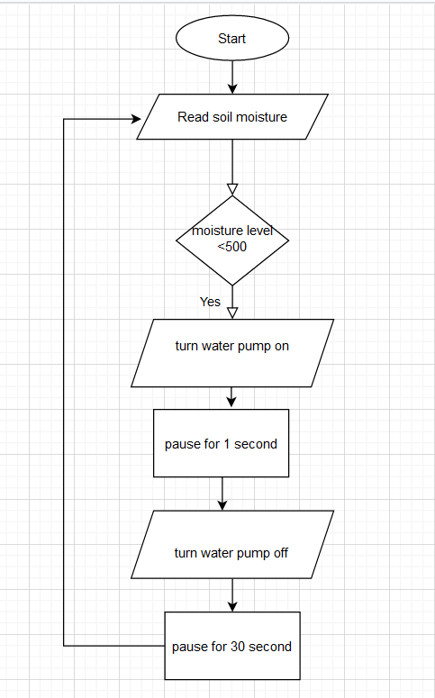

Build the Circuit:
  - Materials Required:
- Edge I/O Adapter for micro:bit
- Micro:bit
- Crocodile clip wires
- Gator:soil micro:bit
- Screw driver
- Battery Pack
- Five jumper wires
- 5V high/low level trigger relay
- One Crocodile clips
- Pump
- Pump Tube
- Cup of Soil
- Cup of Water

  - Hardware Hookup:
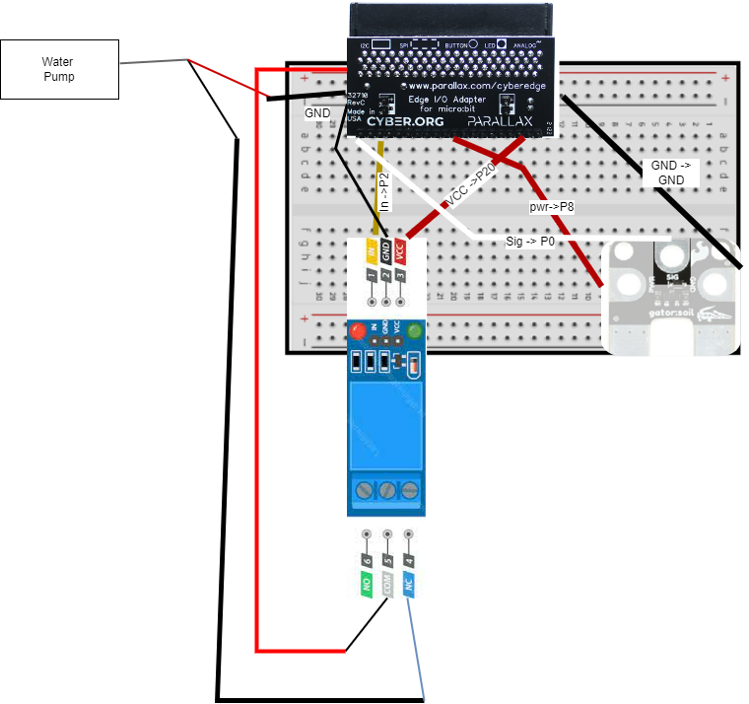
  - Figure 1.

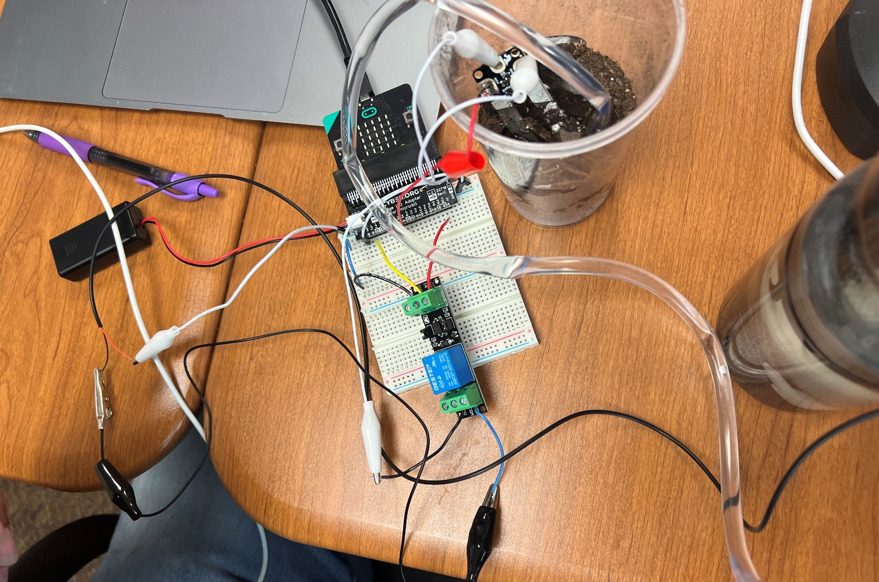
  - Figure 2.

Let’s Start Programming!

Step 1: Getting Started

First, obtain the gatorSoil extension by typing, “gator soil” in the extension search bar. Now, we have all the drawers needed for this project. Next, create a function and name it, “soil_moisture”. Now, create a variable called moisture and set it to the gator soil block. Change the gator soil block to pin p0 in moisture(variable) using power pin P8. Finally, grab an if else block and the condition should be if moisture(variable) < 0.5. Place the digital write pin P2 to 1 and else digital write pin P2 to 0.

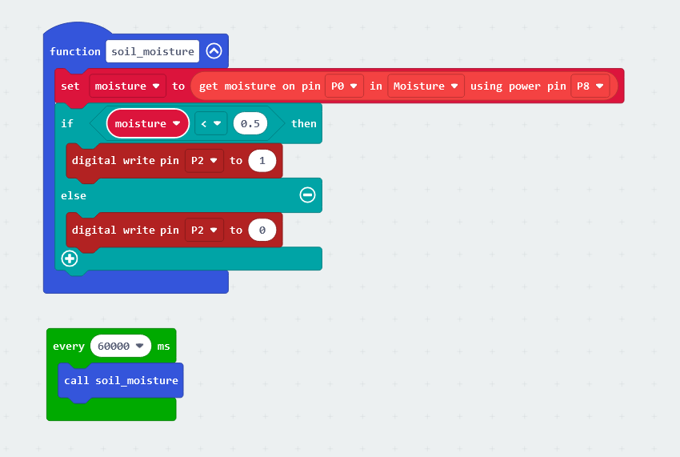

Figure 3.
Step 2: Selection Changes
The threshold should be adjusted based off plant.
Step 3: Test your Program using the Emulator
Step 4: Download the Program
Step 5: Connect to your micro:bit
Step 6: Running the Program on the micro:bit

Congratulations!
You have created your water pump function program!!

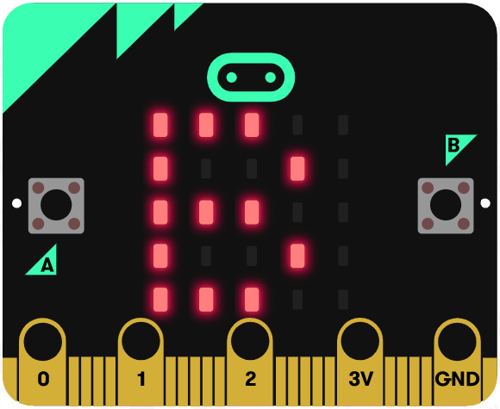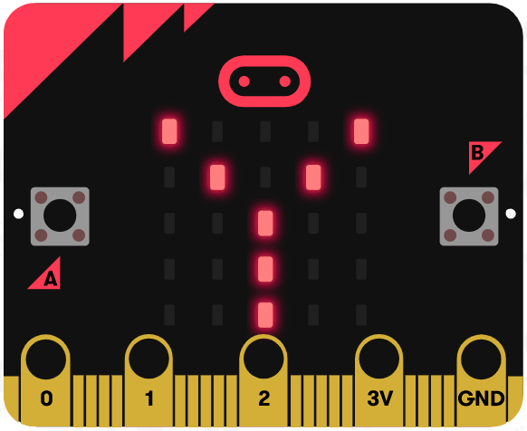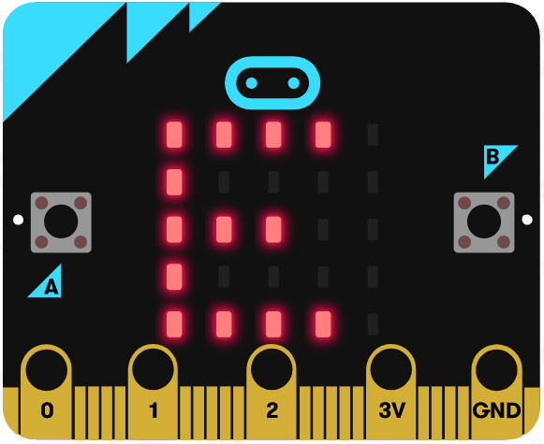

References
Flowchart tool: https://www.draw.io/

